Student Threat Assessment Guidelines

November 2022

Provided for use by Eaton Regional Education Service Agency

Talking Points for Staff

The following talking points can be used in conversation with staff to explain the purpose of the threat assessment system.

- It is our obligation as a school to make sure our school is safe for both students and staff.
- If you observe a situation, in which a student makes a threat, tries to hurt someone physically, or says or writes something that worries you because it might lead to harm to the student or others, report it to administration right away.
- When a student is involved in any potentially dangerous circumstance—ones that involve a threat, an act of violence, or even a concerning communication—it is our job to investigate and if necessary, intervene to ensure the safety of everyone in our school.
- In responding to some situations, it may be necessary for our school to conduct a
- formal threat assessment of a student who is involved in a dangerous behavior or
- circumstance
- The purpose of the assessment will be to gather enough information from all appropriate sources (e.g. staff members, parents, etc.) to make good decisions about how to intervene effectively to manage the situation or the student concerned.
- You, as a staff member, may be invited to participate, or you may be asked to complete a brief teacher interview form that will provide the team with important information.
- Once the assessment is complete, we may need to invite outside professionals to conduct follow up assessments or support intervention efforts.
- We would call in such a team if we needed more information about risk or if we were concerned that we could not manage the situation safely without community assistance and resources.
- By participating in this approach, we can help keep all of us safe.

When to Conduct a Threat Assessment

The following is a non-exhaustive list of situations in which a school administrator should consider conducting a Threat Assessment:

- When a student is arrested for weapons possession, assault, menacing or harassment, at school or in the community
- When a student brings or has a weapon at school
- When you receive information that a student may be planning to attack one or more students or staff members at school
- When a student has directly threatened another student or staff member or has a targeted list
- When a physical attack by a student did or could have resulted in serious injury to another student or staff member
- When a student displays an escalating pattern of aggressive/violent behavior
- When students or staff members report being fearful of a particular student
- When a student displays a high level of anger clearly inappropriate to a given provocation or event
- When a student expresses violent ideation in verbal speech or writing
- When a student justifies the use of his own aggression or violence to solve a problem

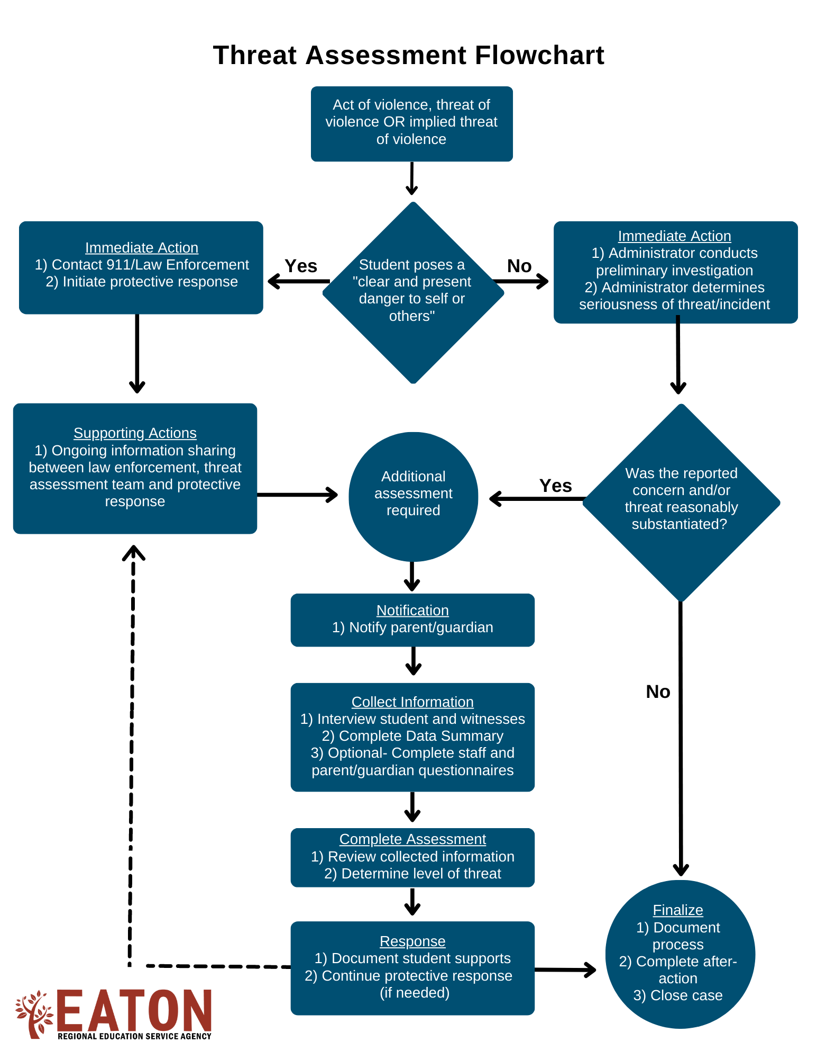

Threat Assessment Process & Classification

The threat assessment process is designed to identify and assess risks in a deliberate and thorough manner through interviews with the student, witnesses, and threat recipients. In determining response strategies to mitigate the risk and provide support and protection, it is helpful to classify threats by level. The threat assessment is conducted and threats are classified as described below.

Student Interview: | Witness/Recipient Interview:
- Do you know why I wanted to talk with you?  - What happened when you were [place of incident]?  - What exactly did you say? And what exactly did you do?  - What did you mean when you said or did that?  - How do you think he/she feels about what you said or did?  - What was the reason you said or did that?  - What are you going to do now that you have made this threat? | - What exactly happened when you were [place of incident]?  - What exactly did [student] say?  - What do you think he/she meant when saying that?  - How do you feel about what he/she said or did?  - Why did he/she say or do that?
Determine whether threat is clearly transient or substantive:
A transient threat meets one or more of the following:  - Threat is vague and indirect  - Information is inconsistent, implausible, or lacks detail  - Non-sustainable intent to harm  - Student is unlikely or incapable of carrying out the threat  - Inappropriate verbal comment, drawing, or gesture that does not intend to threaten violence  - Temporary feelings of anger  - Intended as joke or figure of speech  - Resolved on scene or in office (time-limited)  - Conflict is resolved and ends with apology, retraction, or clarification  - WHEN IN DOUBT, consider threat as substantive and assess further | A substantive threat meets one or more of the following:  - Threat has been repeated over time or related to multiple persons  - Threat is reported as a plan or planning has taken place  - Recruitment of accomplices or invitation for an audience  - Physical evidence of threat (e.g., lists, drawings, written plan)  Factors to consider in which substantive threats are more likely:  - Age of student  - Credibility of student  - Documented history of aggression
 | Determine if substantive threat is serious or very serious:
 | Serious:  - Threat could be carried out although plan may not be realistic and/or imminent  - Includes a general indication of place and time but falls short of a detailed plan  - No indication that the student has taken preparatory steps toward implementation  - Threat to assault | Very Serious:  - Threat is direct, specific, and highly plausible  - Plan includes details such as a specific victim, time, place, and method  - Student is capable of carrying out the threat  - Clear and immediate danger to the safety of self or others  - Steps have been taken to implement the plan (ex: acquisition of weapon)  - Threat to kill, rape, or inflict severe injury or threat involving the use of weapons

Sample Parent Notification Letter

Date

[Parent/Guardian Name]
[Address]
[City] [State] [Zip Code]

Re: Threat Notification

Dear:

Today we were made aware of a threat (or dangerous behavior) exhibited by your child. It is our district practice to take all threats and aggressive behavior seriously. My initial inquiry into the situation warrants further assessment. School personnel will be completing the assessment of the situation. This may include individual interviews with you, your child, and others involved in the incident.

Thank you for your support in addressing this serious matter. If you have any questions or concerns, please contact me at [CONTACT PHONE AND EMAIL].

Sincerely,

[Administrator Name]
[Administrator Title]

Student Threat Assessment
Forms

[Page Intentionally Left Blank]

